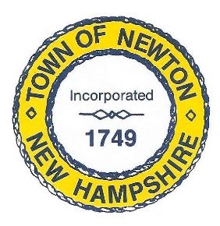

HELP WANTED
TOWN OF NEWTON
Part-time Lifeguards

The Newton Board of Selectmen is currently seeking part-time lifeguards to work from June 1, through September 2, 2024 at the Town Beach on Country Pond.

Lifeguards are responsible for safely managing the Waterfront environment at the Town Beach on Country Pond. Duties include patrolling the swimming area and monitoring swimmers; Performing rescue maneuvers, CPR & First Aid as necessary; Ensuring that maximum safety precautions are practiced, and rules and regulations are followed by all beach patrons; and communicating effectively to enforce safety regulations.

Candidates must be at least 16 years of age and possess a current Lifeguard Certification from the American Red Cross, YMCA, YWCA or other recognized organization; possess a current American Red Cross CPR for the Professional Rescuer or American Heart Association Heartsaver certification or comparable; and certification in Standard First Aid.

Are you interested in being a lifeguard but not certified? Successful applicants will receive tuition reimbursement for a lifeguard certification class if they work for the Town through the entire summer.

Pay is commensurate with experience of $18 - $20 per hour pending funding. Incentives will be awarded for attendance and commitment. Lifeguard clothing will be provided.

Interested applicants should send their letter of interest and/or resume to the Recreation Commission, 2 Town Hall Road, Newton, NH 03858 or email to recreation@newtonnh.net.

