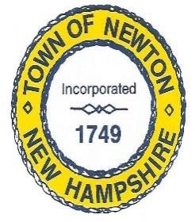

American Rescue Plan Act (ARPA) Workgroup Minutes

DATES: 11/7/22 TIME: 1pm Location: Fire Department

Members present: McCarthy, Simone, Alcaidinho, Jewett, Kozec,
Guest: Mark Andrews

- Generator: requisition for Tri-State has been sent to BOS for approval/signature

- Transfer Station: requisition submitted for to BOS for the engineering ($1750.00) for well/septic

- Camara’s/security= FM Valenti Company: we have not visited the headquarters for this company yet. Discussed that we may not want to spend a huge amount of money for camaras. Maybe we should fine-tune the locations for camaras needed. Remove the camaras at Greenie Park, Beach and Peanut Trail. Fire Chief said we only need one or two camara’s at FD, and to remove the camara quote for Station Two.

- Quote for Large town printer: will be delivered 11/15/22. The set up will include training for Daine, Mark, Jim and Trisha.

- Antenna & desk equipment for Police Dept: has been ordered. Chief Jewett will keep up posted when it arrives and is installed

- Website Company: John Guilfoil (ask BOS for a decision). The workgroup feels this is a much needed service for our community to be kept up-to-date on an improved town website. Last Jack asked if there is a way to find out how many people actually go to the website? After checking into this, it seems we had about 2200 visitors on the current website. (that includes employees using it to). Diane had concerns about how many times a month each department can post items like, minutes, agendas, hearings, and plans from planning board. The work group decided to check with BOS for their input.

- Bultler Building: hoist for bay doors: have been installed and working

- Greenie Park: Town Engineer told McCarthy he will be in the area of Greenie Park and will take a look at it. Also told him that Mike Pivero has looked at the property and feels we need to cut back about 100’ of trees on parking lot side of property.

- Simone asked Chief Jewett about the portable lighting he wants. Jewett said he believes the company is Wanco and will get back to us on price.

Adjourn

